Implementation Evidence
Implementation Evidence
The project was implemented in ServiceNow using Flow Designer. The implementation includes the creation of the Incident Workflow table, configuration of required fields and dependent choices, development of the Auto Classify School IT Tickets flow, keyword-based ticket classification, and automated email notification. The following screenshots provide evidence of the implemented components and configuration.

Update Set Configuration

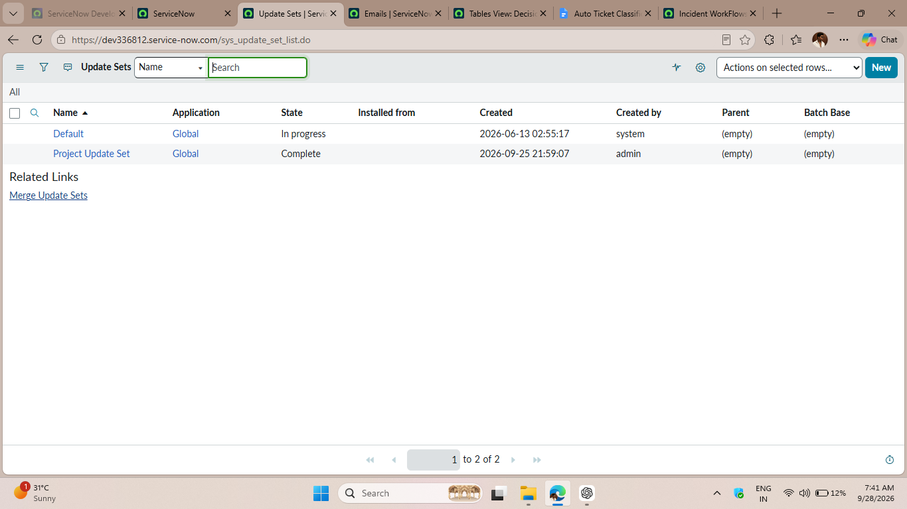

Incident Workflow Table
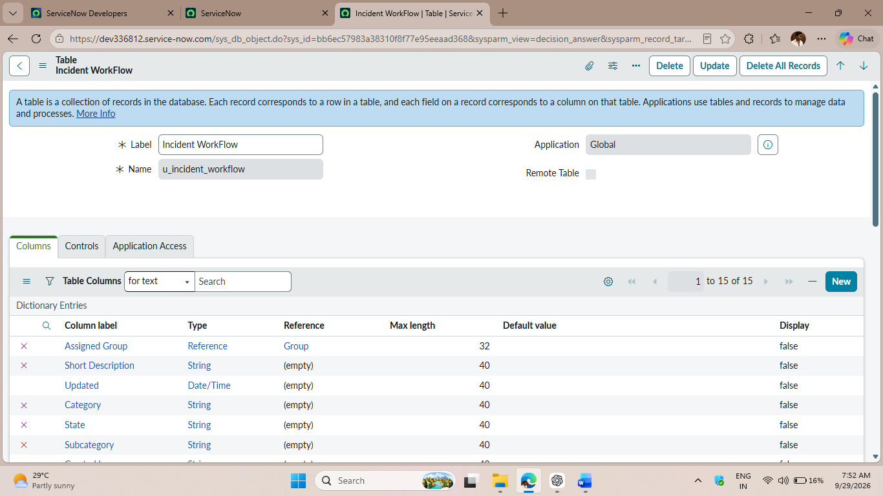

Field Configuration

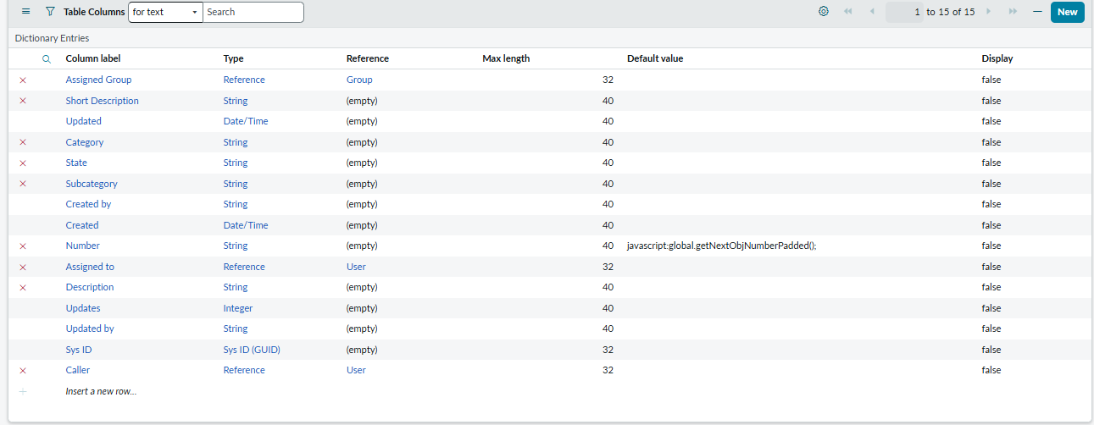

Dependent Choice Configuration
- 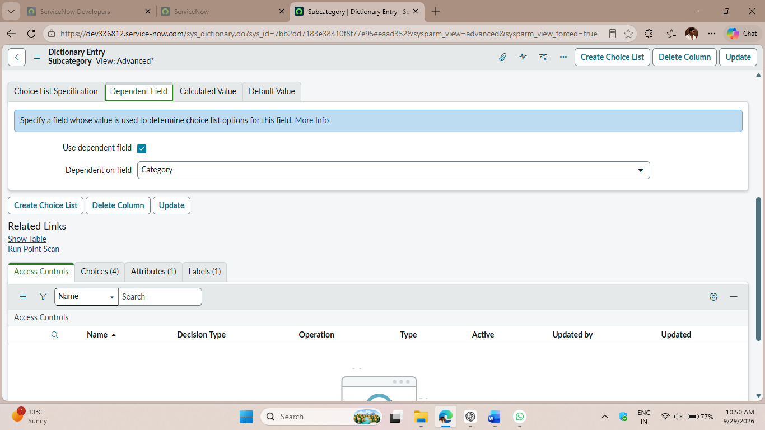

5. Flow Designer Configuration
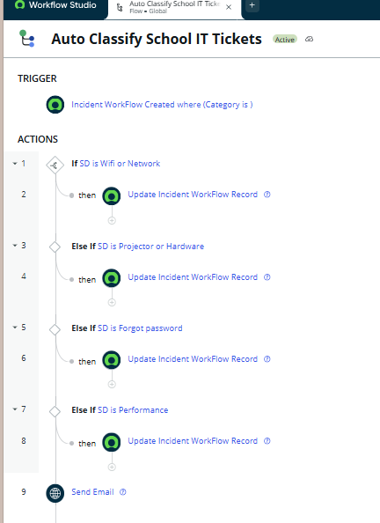

6. Email Notification
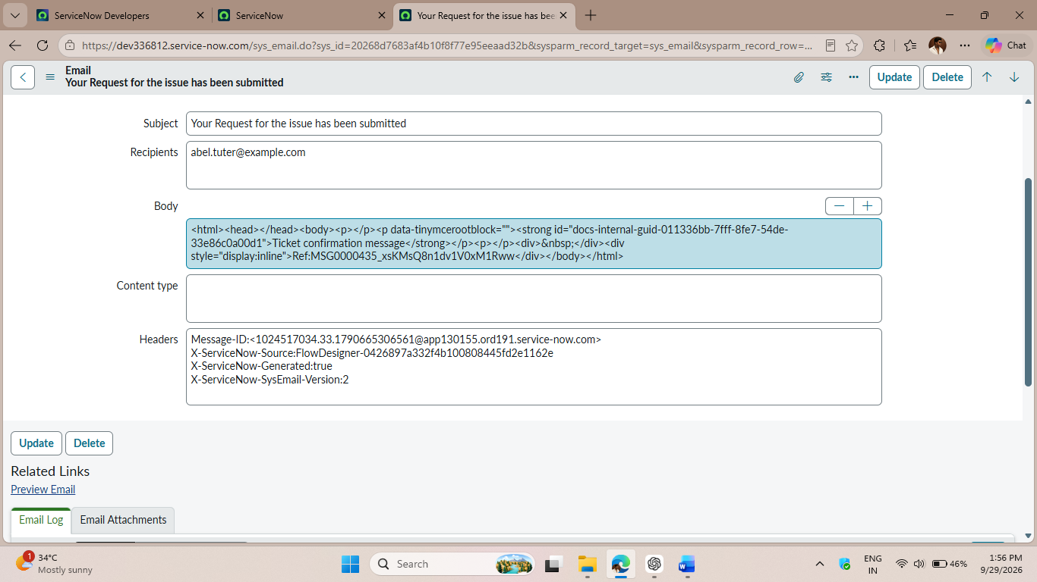

7. Implementation Result
The implemented workflow successfully classifies IT support tickets based on the Short Description, assigns the appropriate Category and Subcategory, and sends an automated confirmation email to the caller.
